**SACRED HEART GIRLS’ COLLEGE**

**OAKLEIGH**



**Mathematical Methods CAS 2012**

**Unit 3 SAC 3: APPLICATION TASK**

**PART B**

**Name: ________________________________**

**Teacher (please circle)**: Ms Gates Mr Smith

**Part B: 3 extended response questions.**

**Two A4 sheets of summary notes(double sided) and CAS permitted**

**Reading: 5 minutes**

**Writing: 75 minutes**

**EXTENDED RESPONSE**

**Instructions:**

Answer **all** questions in the spaces provided.

In all questions where a numerical answer is required an exact value must be given unless otherwise specified.

In questions where more than one mark is available, appropriate working **must** be shown.

Unless otherwise indicated, the diagrams in this test are **not** drawn to scale.

**Question 1**

Dorothy Smart is preparing for her mid-year exams. She realises that as well as being academically prepared she needs to ensure she is in peak physical condition. A key measure of general health and well-being is core body temperature. Dorothy’s temperature is generally modelled by the function

$T\left(t\right)=asin\left(\frac{π}{12}(t-2)\right)+b$ for $0≤t≤20$

Where *T* is her temperature in °C and t is time in hours after 6 am. *a* and *b* are positive real constants.

1. On Monday, Dorothy’s temperature at 6am is 36.75°C and at 6pm it is 37.25°C.

Write two equations we could solve to find that $a=\frac{1}{2}$, and $b=37$.

2 marks

1. What is Dorothy’s temperature at 8am?

1 mark

1. What is her maximum temperature and when does it occur?

2 marks

1. Over a 20 hour period, for what value(s) of t is the rate of change of Dorothy’s temperature **first** at a minimum?

1 mark

1. Find the maximum rate of change of Dorothy’s temperature and the time(s) at which this occurs

2 marks

Experts recommend that when sitting exams it is ideal to have a body temperature of at least 37.3°. Between what times, to the nearest minute, would her exams need to be to meet this condition.

2 marks

**Question 2**

On Monday night, Dorothy gets sick and develops a fever. Her temperature is now modelled by the function $g\left(t\right)=at^{3}+bt^{2}-115t+874$ where *T* is her temperature in °C and t is time in hours after 6 am on Monday. *a* and *b* are real constants.

$g\left(t\right)$ joins smoothly with $T(t)$ at the point $(20, 36.5)$.

1. Write the equations we could solve to find that $a=-\frac{5}{64}$ and $b=\frac{167}{32}$.

2 marks

1. On the axes below, sketch the graphs of

$T\left(t\right)=0.5sin\left(\frac{π}{12}(t-2)\right)+37 for 0≤t≤20$ and

$$g\left(t\right)=-\frac{5}{64}t^{3}+\frac{167}{32}t^{2}-115t+874 for 20<t≤\frac{368}{15}$$

Label endpoints with coordinates.

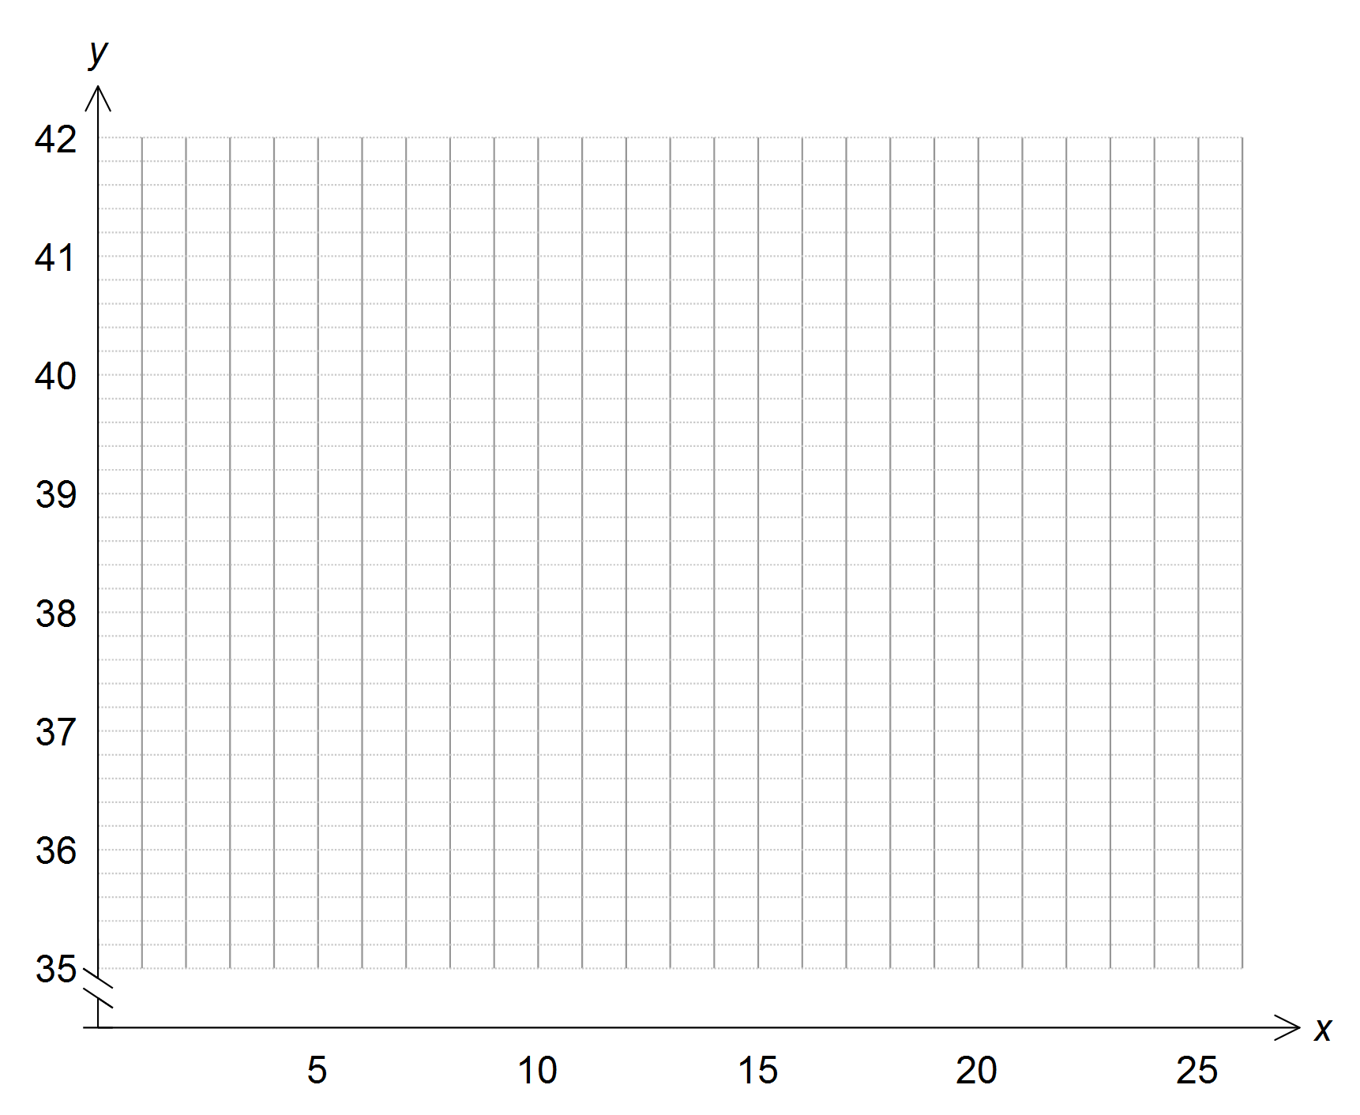

3 marks

1. What is the average rate of change of Dorothy’s temperature between 4am and 6am on Tuesday?

1 mark

1. What is the rate of change of Dorothy’s temperature at 5am on Tuesday correct to two decimal places?

1 mark

**Question 3**

With her temperature spiking to dangerously high levels, Dorothy is rushed to the emergency department at the local hospital. In an effort to reduce her temperature, doctors prepare the correct dosage of some medication.

The blood concentration of the drug can be modelled by the function

$$c:\left[0,16\right]→R, c\left(t\right)=at^{2}e^{-bt}$$

where *c* is the concentration of the drug in mg/litre and *t* is the time in minutes after the drug has been administered.

The absorption time of the drug is defined as the time it takes for the drug concentration to reach its maximum value.

1. Let $a=1$ and let $b=0.25.$ Sketch the graph of $c(t)$ on the axes below. Label endpoints with coordinates. Express answers correct to two decimal places.

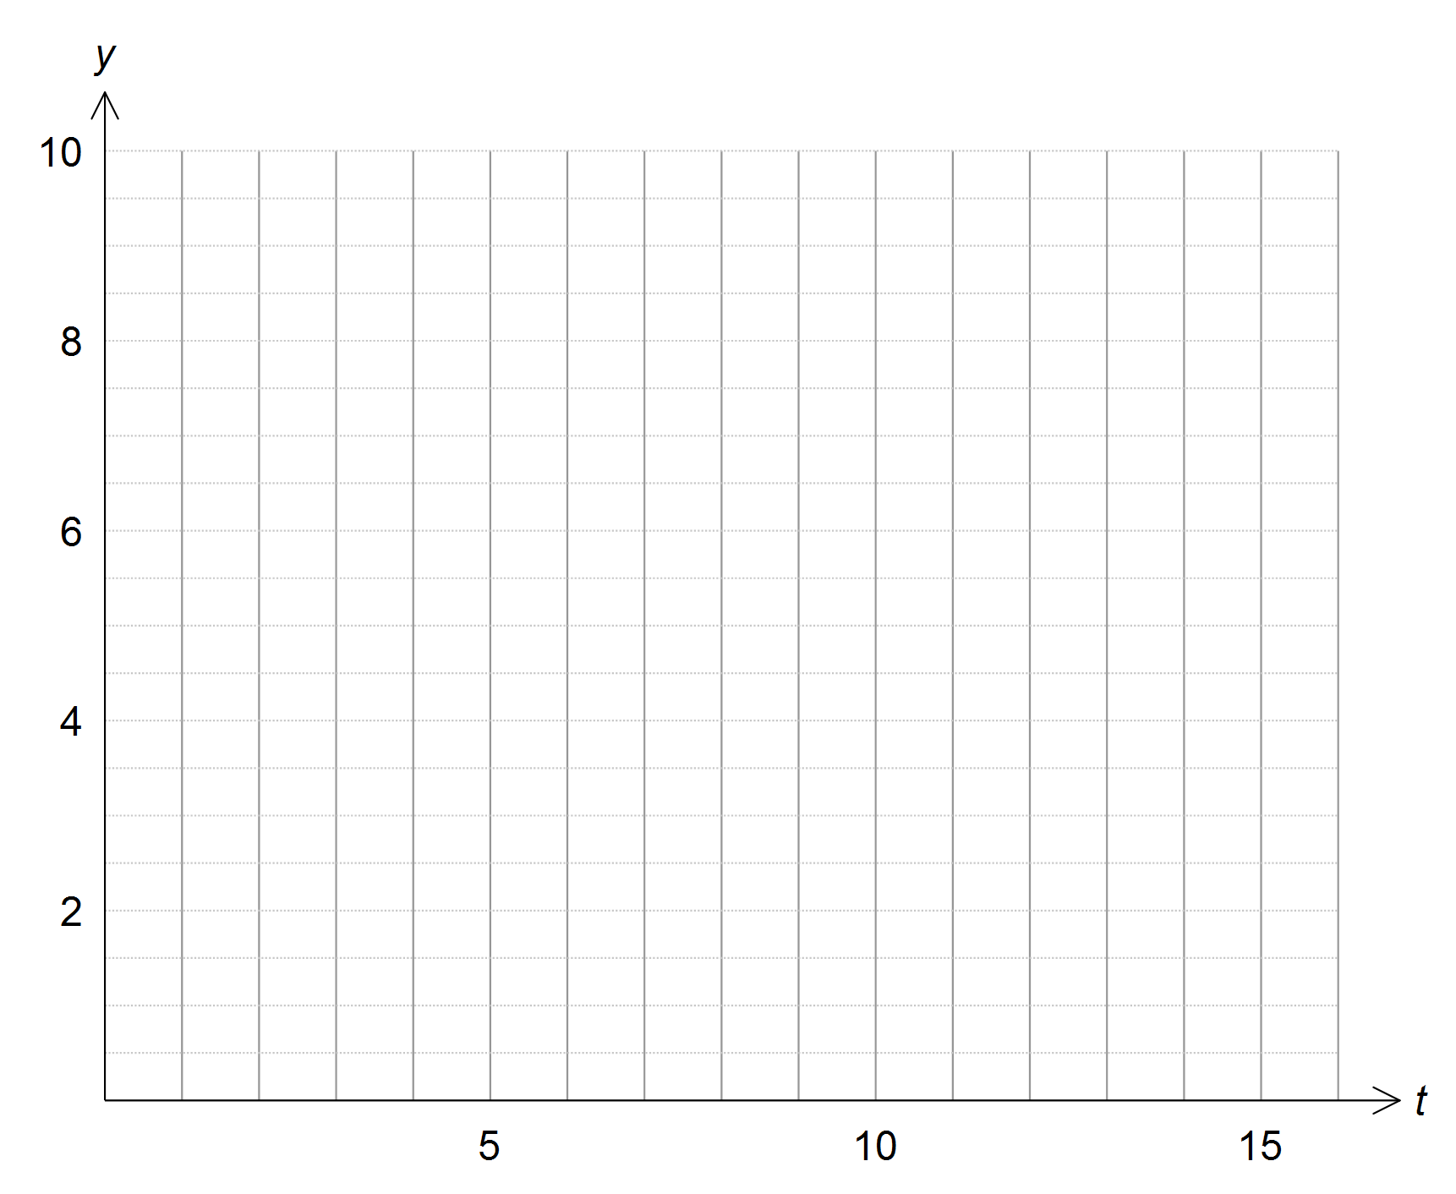

2 marks

1. If $c\left(t\right)=t^{2}e^{-0.25t},$ find $c'(t).$

2 marks

1. Hence find the absorption time of the drug and the maximum concentration correct to two decimal places.

2 marks

1. If the doctor wants to increase the maximum concentration of the drug in the blood stream but not affect the absorption time, should they vary “*a*” or “*b*”? Explain.

2 marks

1. Justify your answer to part d above by sketching $c\left(t\right)$ and two other graphs on the axes below. Label the coordinates of the maximum. Express answers correct to two decimal places. (You do not need to label endpoints)

|  |  |
| --- | --- |
| $$f1(x)=$$ | $$f2(x)=$$ |

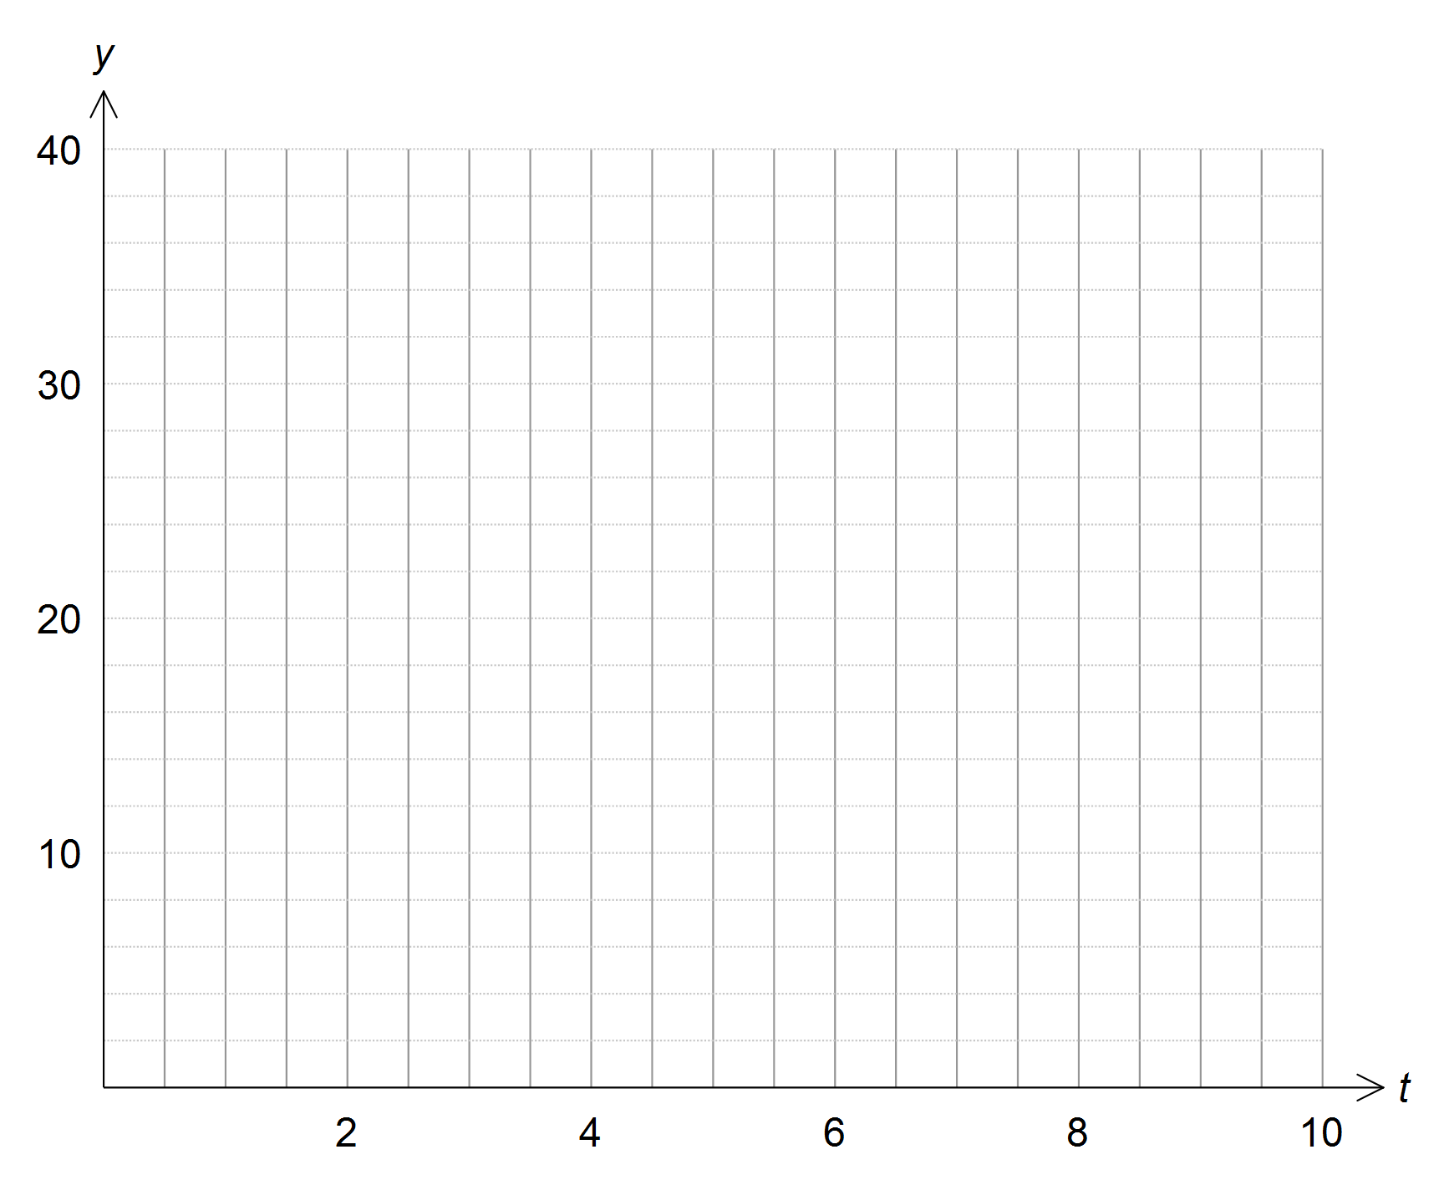

4 marks

Once the correct dose is administered, Dorothy’s temperature is modelled by the function

$N\left(t\right)=42cos⁡\left(\frac{t}{82}\right)$ for $t≥24.5.$

Where *N* is her temperature in °C and *t* is time in hours after 6 am on Monday.

Dorothy’s first exam is Tuesday at 5pm.

1. Find her temperature at that time correct to two decimal places.

1 mark

END OF SAC